# 

# GUJARAT TECHNOLOGICAL UNIVERSITY

**Chandkheda, Ahmedabad**

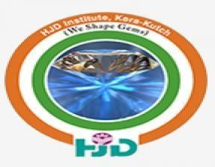



A Project Report On

**“Digi-Res (Resume Making) “**

**Under subject of**

**DESIGN ENGINEERING**

**B. E. Semester – 6th**

**(Computer Engineering Department)**

**Submitted by:**

|  |  |  |
| --- | --- | --- |
| ***Sr.No*** | ***Name*** | ***Enrollment No.*** |
| **1** | **Vaibhav Abhaybhai Shah** | **190850131013** |
| **2** | **Mirani Swati Bhaveshbhai** | **190850131007** |
| **3** | **Ankit Kumar** | **190850131001** |
| **4** | **Hetal Gadhvi** | **190850131003** |

**(Faculty Guide) (Head of the Department)**

Mr. Ayar Priyanka Mr. Vishal Bhimani

Prof. Computer Department Head Of Department

**HJD Institute of Technical Education and Research, Kera Kutch**



CERTIFICATE

This is to certify that ***Mr. Shah Vaibhav Abhaybhai, Ms. Swati Bhaveshbhai Mirani, Mr. Ankit Kumar, Ms. Hetal Gadhvi*** from **HJD Institute of Technical Education and Research** College having Enrollment no. ***190850131013, 190850131007, 190850131001, 190850131007*** has completed Semester-VI Design Engineering Project Report having title

**Digi-Res (Resume Making)** in a group consisting of 4 persons with **Team ID: 356474** under the guidance of the Faculty Ms. Ayar Priyanka Manjibhai.

**External Examiner**

**Internal Guide Head of Department**

**MS. AYAR PRIYANKA Mr. Vishal Bhimani**

**ACKNOWLEDGEMENT**

This project idea is by far the most significant accomplishment in our life and it would be impossible without people who supported us and believed in us. We would like to extend our gratitude and sincere thanks to our honorable, esteemed supervisor Prof.PRIYANKA AYAR . He is not only a great teacher/professor with deep vision but also and most importantly a kind person. We sincerely thank for her exemplary guidance and encouragement. She trust and support inspired us in the most important moments of making right decisions and we are glad to work with him. My special thanks go to Prof. POOJA GUSAI, Head of Computer Engineering Department, for providing us with best facilities in the Department and his timely suggestions.

We want to thank all teachers for providing a solid background for our studies and research there after. They have been great sources of inspiration to us and we thank them from the bottom of heart.

We would like to thank all friends and especially our classmates for all the thoughtful and mind stimulating discussions we had, which prompted us to think beyond the obvious.

|  |  |
| --- | --- |
| ***Name*** | ***Enrollment No.*** |
| Vaibhav Abhaybhai Shah | 190850131013 |
| Mirani Swati Bhaveshbhai | 190850131007 |
| Ankit Kumar | 190850131001 |
| Hetal Gadhvi | 190850131003 |

**INDEX**

|  |  |  |  |
| --- | --- | --- | --- |
| **Sr. No.** | **Content** | **Page No.** | **SIGN** |
| **1** | **Introduction** | **5** |  |
| **2** | **Observation record sheet A, E, I, O, U** | **6** |  |
| **3** | **Mind Mapping** | **8** |  |
| **4** | **Empathy mapping canvas** | **10** |  |
| **5** | **Ideation Canvas** | **13** |  |
| **6** | **Product Development Canvas** | **15** |  |
| **7** | **Prototype** | **17** |  |
| **8** | **Learning Matrix Needs** | **22** |  |
| **9** | **Conclusion** | **24** |  |

# 

# Introduction

**DOMAIN Reference** : Resume Building

While a person is applying for a job interview he/she shares a file in a form like doc or pdf as it is unknown to have which format does the interviewer/recruiter want.

So, To make it common and resolve this issue of unsupported files or unwanted format of RESUME. We have created this Website which generates a link of your resume and it is a sharable link which is universally accessible by anybody.

## 

## Design Thinking

Design Engineering is a general term that covers multiple engineering disciplines including electrical, mechanical, chemical engineer, aeronautical engineer, civil, Computer Engineering, Information Technology and structural/building/architectural engineers. The uniting concept is a focus on applying the engineering design process.

## Important

* + For comfortable
  + facilities

**Evaluation of Idea Observation Record Sheet(A,E,I,O,U)**

**Our Journey**

* Our team is visiting sites related resume building and resume promoting.
* We have observe and find data related to activities, environment, interaction, objects, and users.
* During observation our team member is noted all details in note book.

## Activities

* These are goal-directed sets of actions-paths towards things people want to accomplish.
* What are the modes people working, how long do they spend doing something? And the specific.

## Observation

* We have observed during observation related to activities is:
* Resume linking with other webpages.
* Interviewer find difficult to contact recruiters.

***CANVAS***

## 

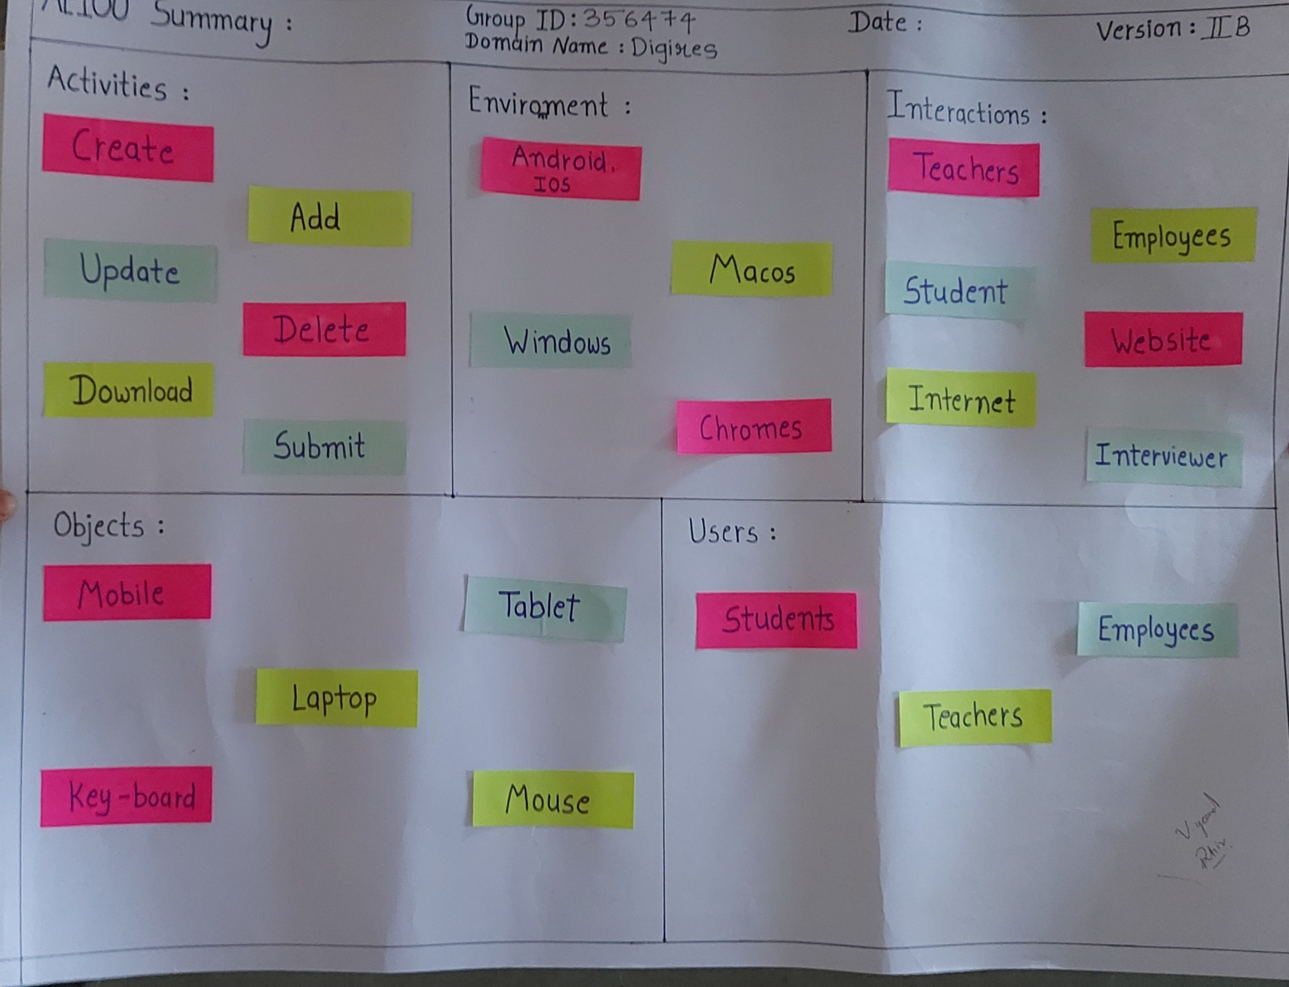

## MIND MAPPING

**DOMAIN: Digi-Res ( Resume making)**

For the mind mapping,

We divided our team members and we had gone on different things of mind mapping on book. Then every member is making a mind map in his log book and atlast we made a final mind mapping on sheet.

Sections of Mind Mapping:

* Application
* Benefits
* Activites
* Types
* Component
* Possible Solutions

***CANVAS***

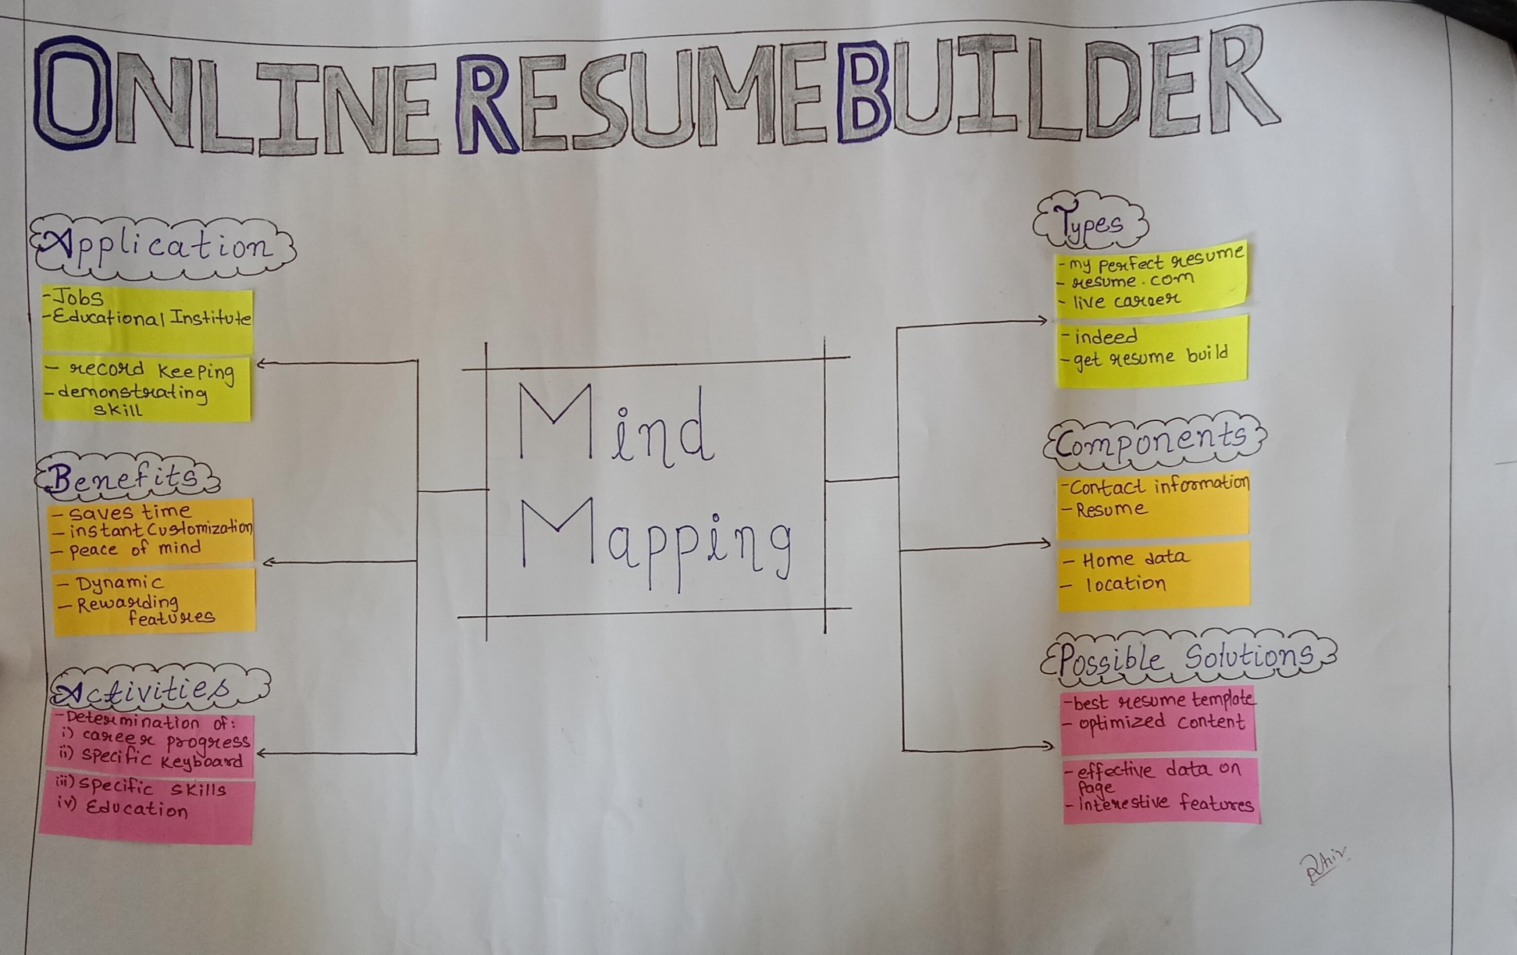

## EMPATHY MAPPING

For the empathy mapping,

We had given access to our project to some people in our surrounding and took there feedback as out stories and try to apply those feedback to our Project to make it better.

People firstly were bias about our project that recruiters won’t like this idea but as soon as they come to know the versatility and usability of our project without any pre-requisites. They were amazed and provided there valuable feedback from the same.

**Empathy Canvas Involves:**

* Types of Users
* Stakeholder of our project
* Activities performed
* Story Building

**People Views**

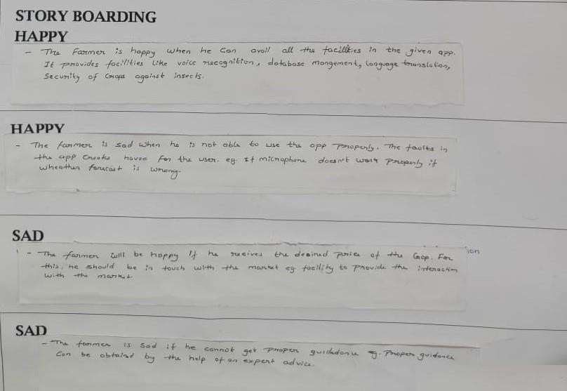

.

**CANVAS**

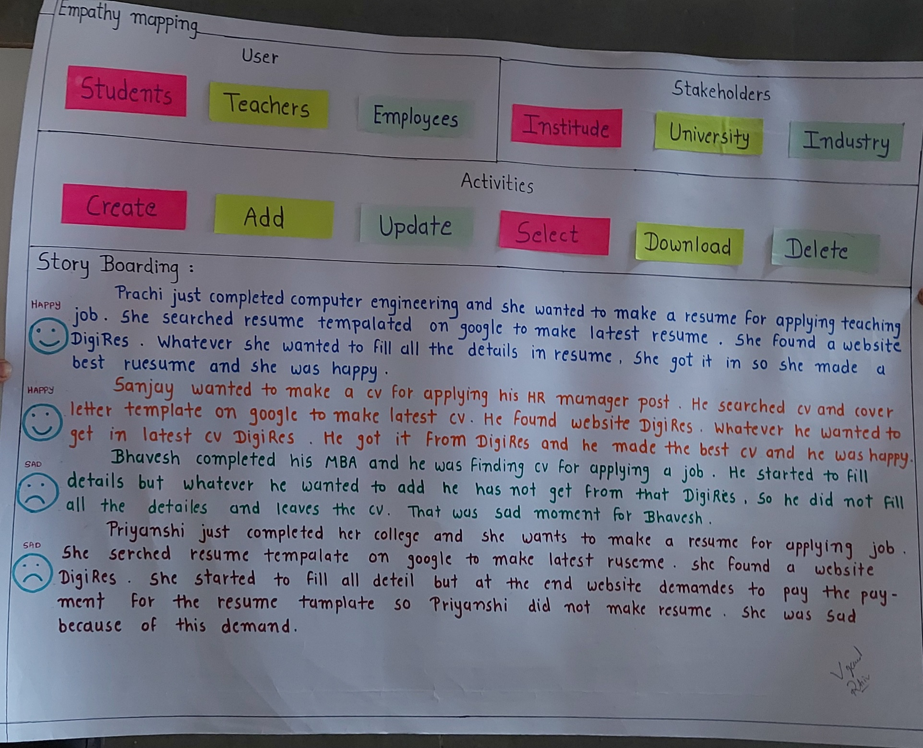

**IDEATION CANVAS**

Ideation Canvas is where first we started with people, where we simply thought about the people for whom we want to solve the problem. For our product we listed the people like engineers, Operators, customer, senior citizen, professors and students. Then list out whatever activity every segment of people do. Then thought for context/location/situation and finally for possible solutions.

We conclude that by implementing system in the future as well as the effectiveness of the System intention we can reduce the effort of our farmers and help them. It includes various Activities such as , database management, voice recognition and expert adviceour.

**CANVAS**

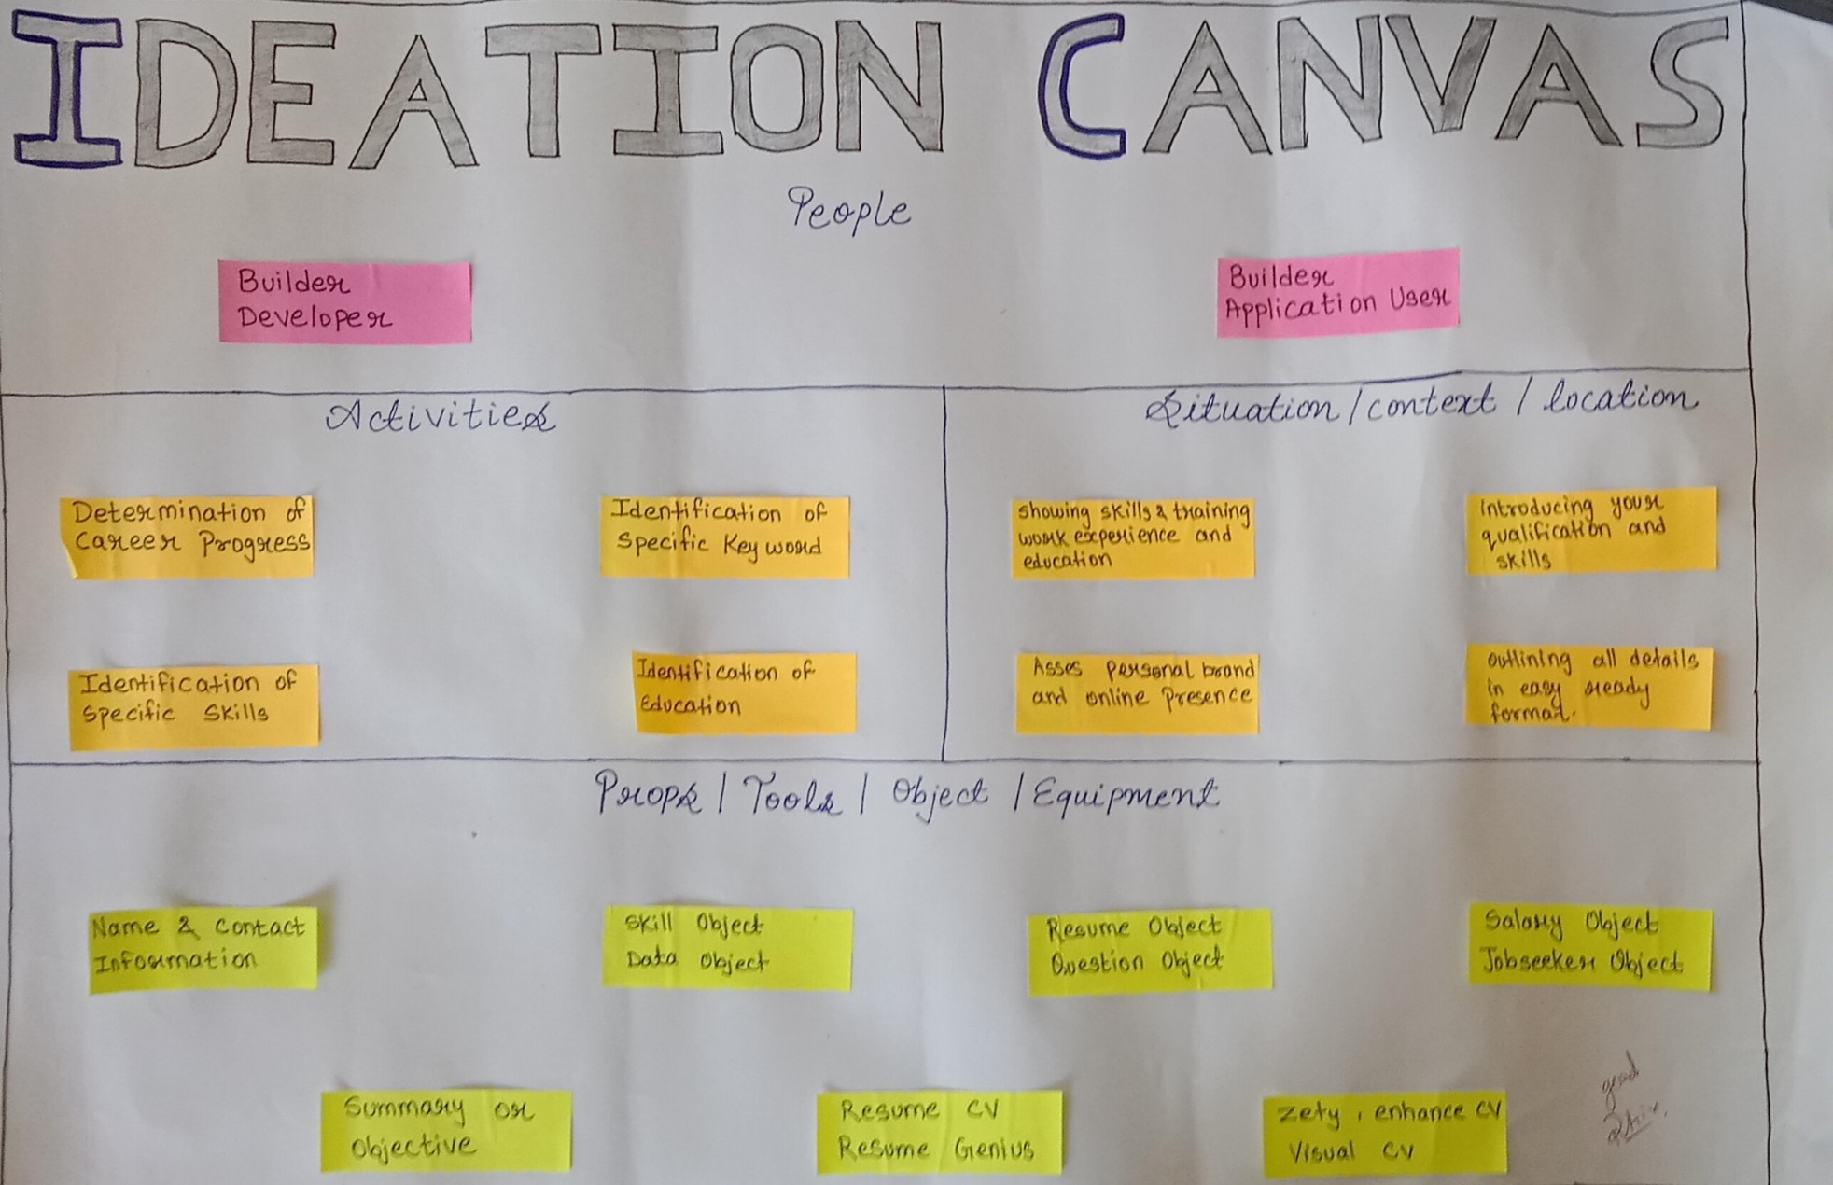

**Products development canvas**

This task was to create **“Product development canvas” .**This canvas is about the solutions to be developed what is purpose,uses,components,features.This all thinks are to be pointed out in this canvas with the canvas.

In this Canvas we have mentioned purpose of our product, functions, features, revalidation

and product’s experience. Purpose of our product is to use Farming Security system with Time schedule to reduce effort of the customers.

The first thing we had to do was clarify the purpose of our product. Our purpose was clear: to easy access and management and help customers.

For this purpose, we defined some functions that our product must do. These included, for each of the function that our product fulfilled, we had to include one or more features that supported that function.

In the next section we had to revalidate our product with the help of customers, who were, for the moment, other teams that were working like us on different designs. Most of our features were validated as extremely useful by other teams.

We had to redesign some features in the next section. These features were both the ones that were extremely useful and the ones that we are moderately relevant. We optimized the features that were useful and made them even better.

There was a section on this canvas where we had to write down about customer experience. Here we had to write what the user would feel when using our product. We wrote about how the work of people to be simplified and how grateful and innovative the user would feel.

## 

**CANVAS**

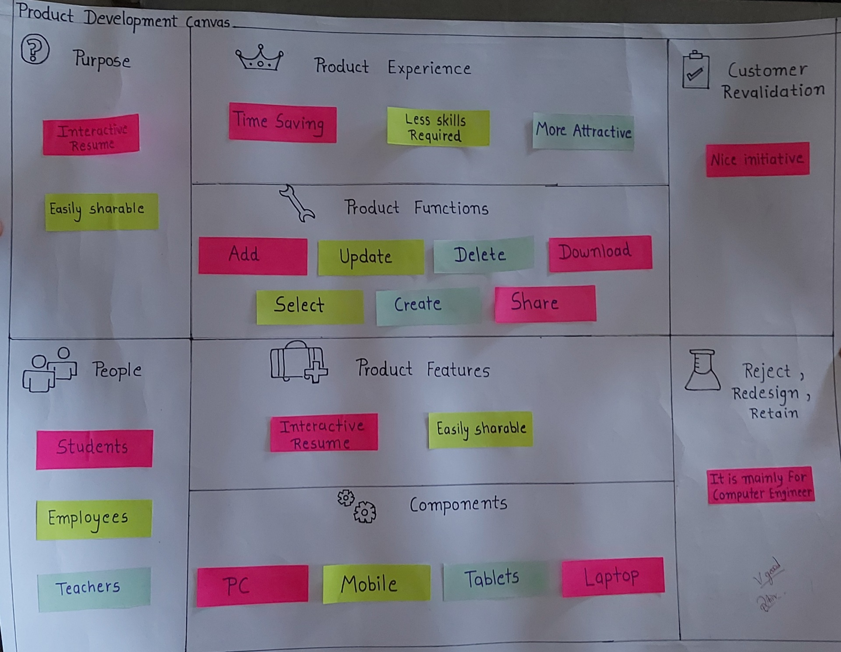

**PROTOTYPE**

**HOME PAGE**

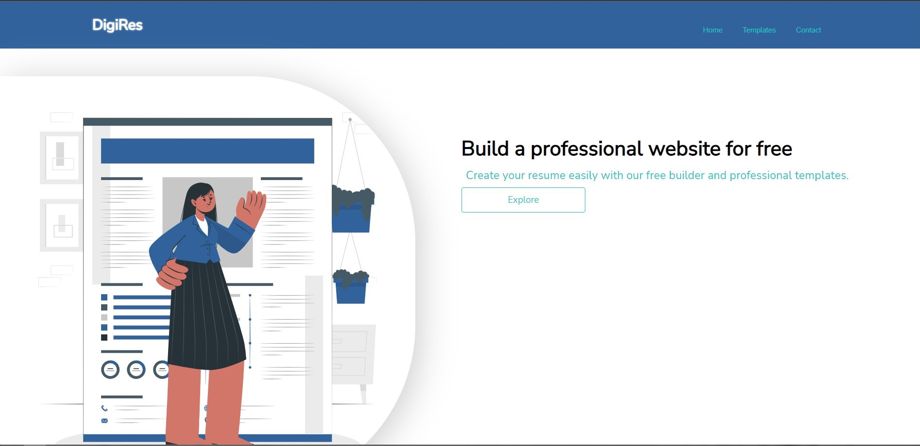

**INFO FILLING**

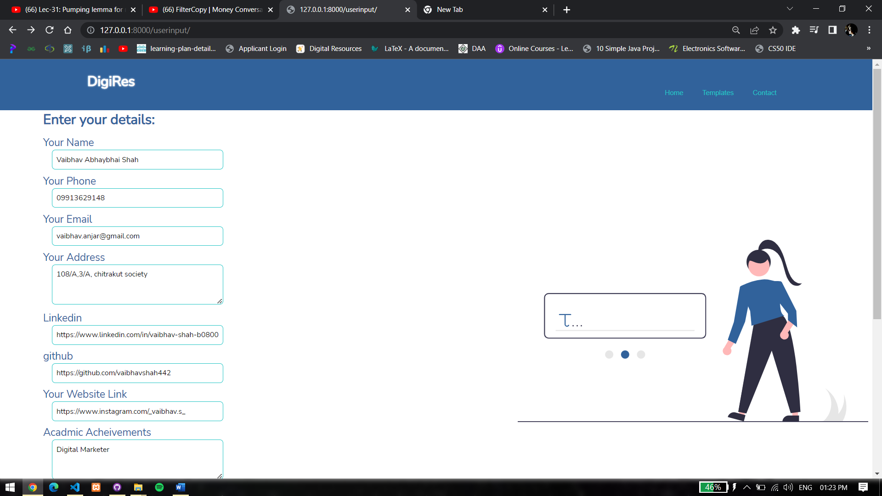

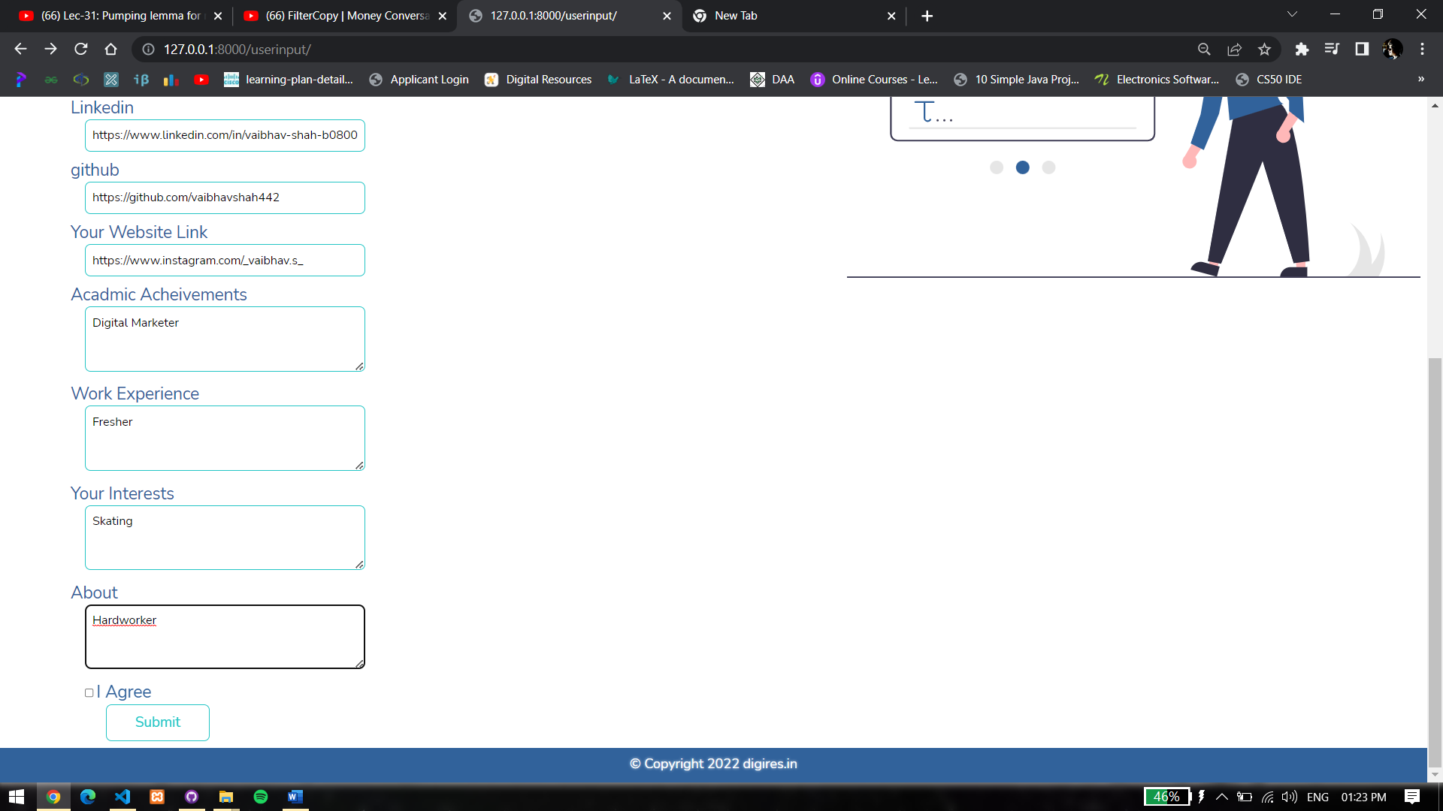

**RESUME SAMPLE**

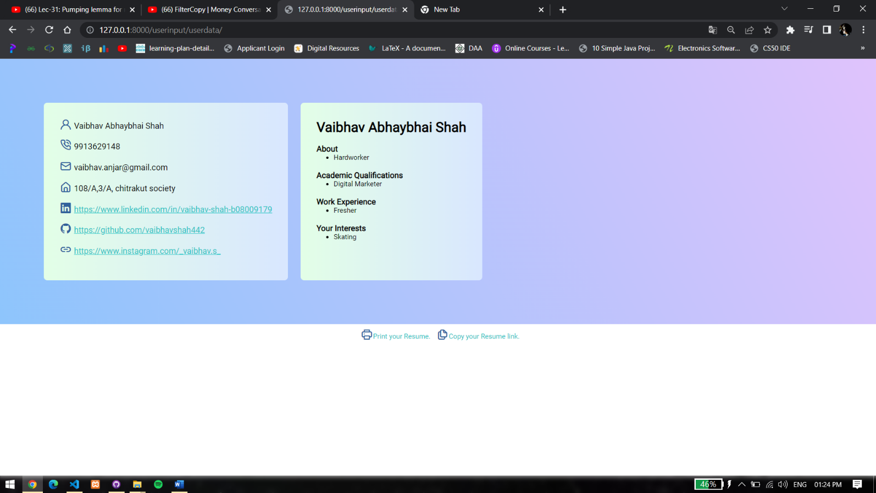

**GENERATING LINK**

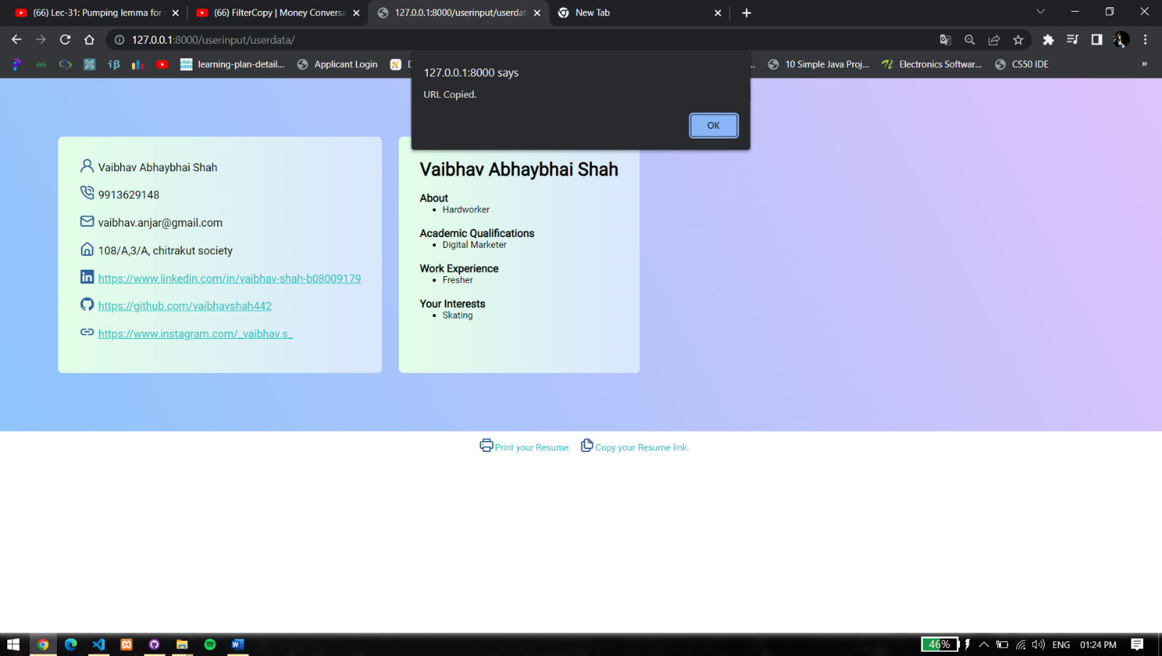

**PRINTING RESUME**

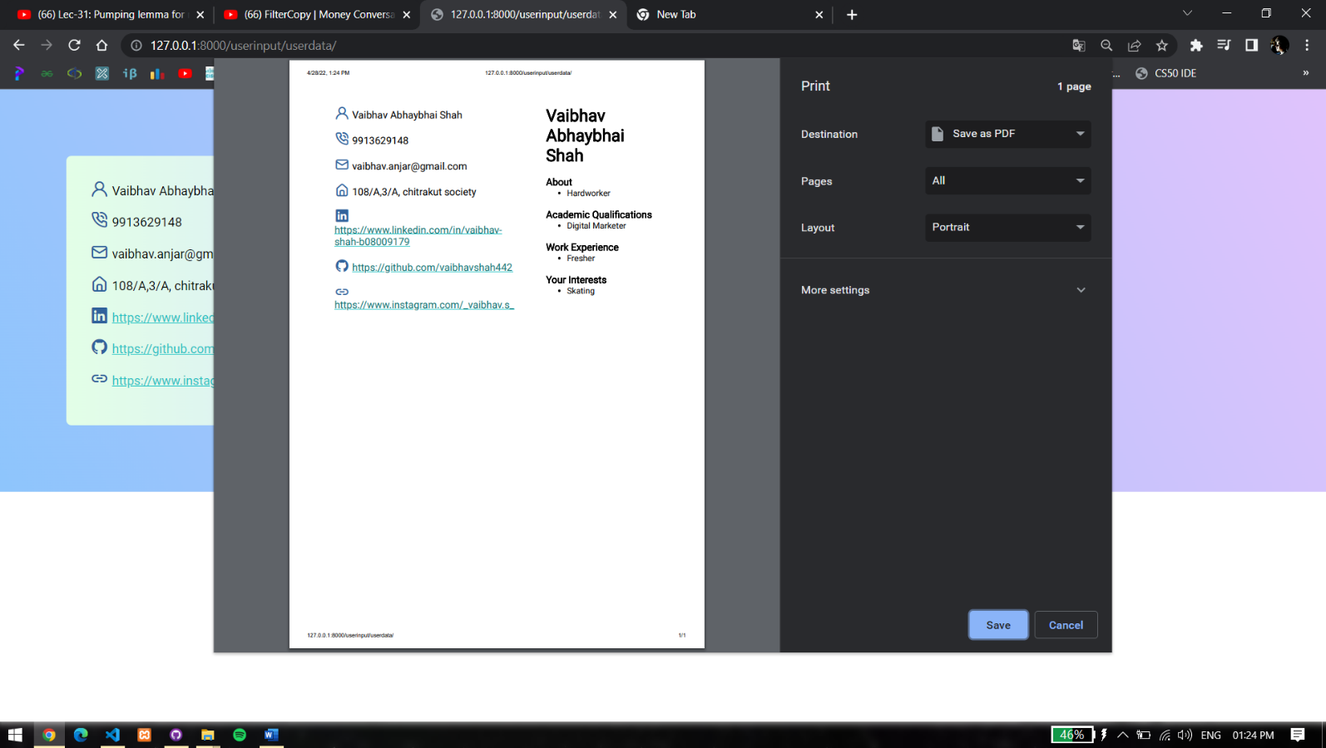

**CANVAS**

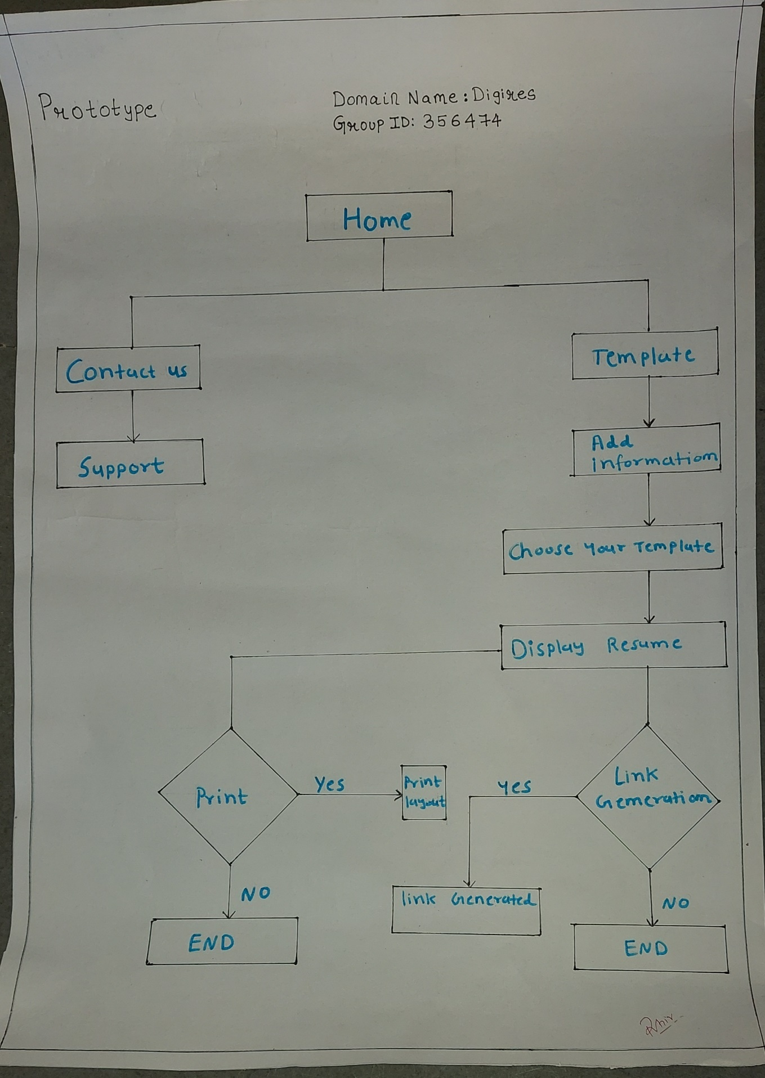

**L.N.M MATRIX**

Learning Needs Matrix will helps us to identify the learning requirements at an early stage along with

prioritization of specific learning along with defined time duration/ time allocation for each learning priority.

## Identification will be focused on listing out both

1. the learning, which is included in some subject of the formal syllabus of our branch and
2. the learning, which is required for solving the Design problem and which may not be included in the formal syllabi of the other subjects

All such learning, required for developing the product, should be considered to be required to be studied for the group of students, who are working on the product. It may include learning of specific

skills.

**CANVAS**

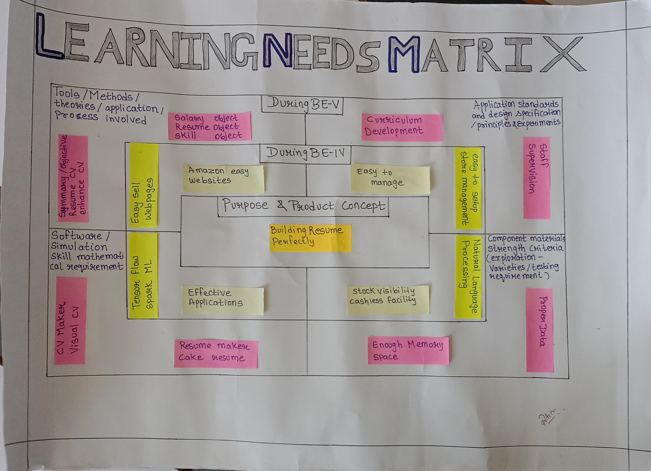

**CONCLUSION**

Our main aim of the project is to provide the useful services to the job seekers by providing the features like resume building, resume linking and much more without waste of any time. We can conclude our report with the list of activities performed in our objects. The information collected by us lead to the following conclusions: We need a wireless or internet connection for the connectivity which uses JAVASCRIPT and CSS programming language. The environment for our project is Androd, IOS, MacOS, and much more. Any person who wants to learn about farming will be the environment. The features and functions of our project lead us to accomplish our project successfully reducing the burdens of the people.